Analysis of tipping structure
1 Tipping structure with no load
This paper shows the deformation and stress results of tipping structure under no-load conditions. All results satisfy the coordinate system shown in Figure 1.
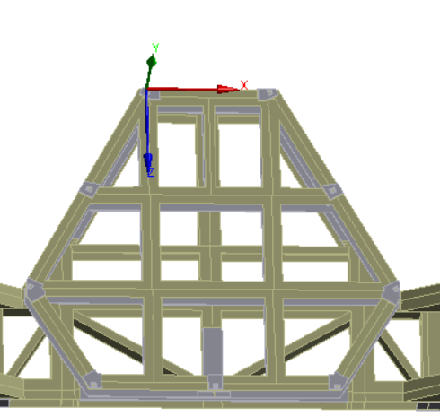
Figure 1 The coordinate system

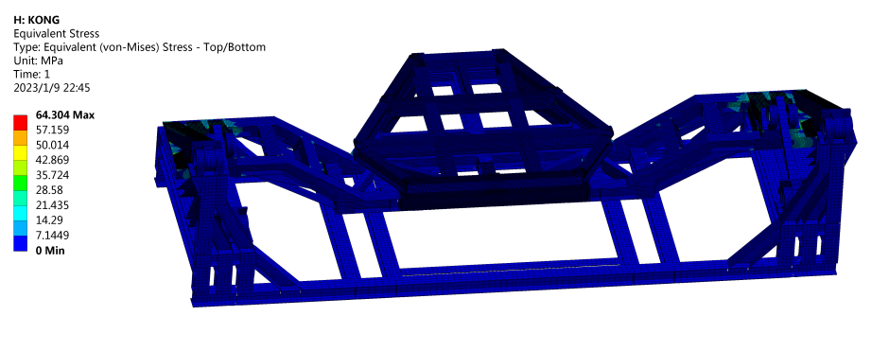
Figure 2 Stress result（0 degrees）
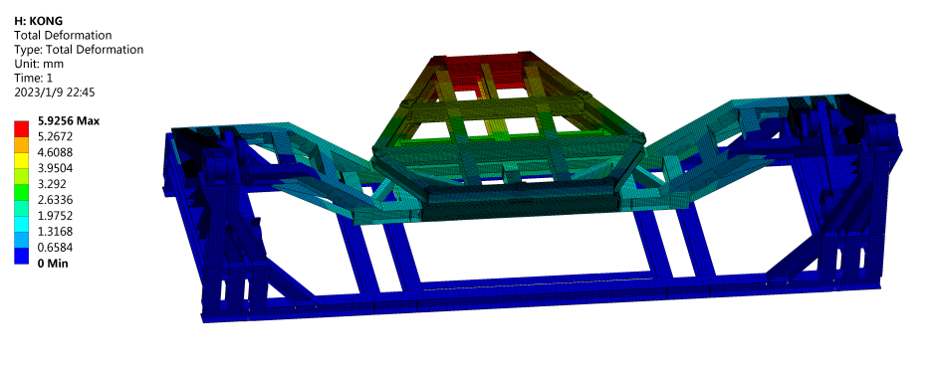
Figure 3 Deformation result（0 degrees）
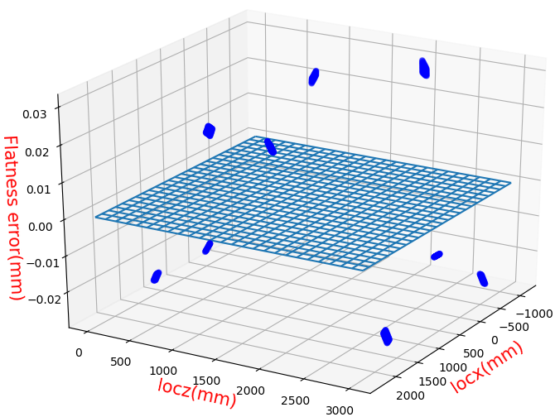
Figure 4 Flatness error of 9 connection points on the interface plate（0 degrees, 28μm）

Figure 5 Stress result（45 degrees）
Figure 6 Deformation result（45 degrees）
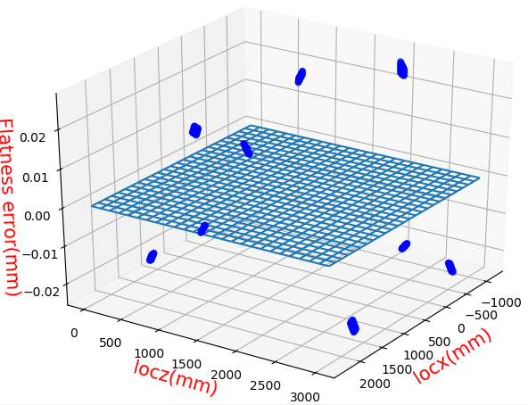
Figure 7 Flatness error of 9 connection points on the interface plate（45 degrees, 24μm）
Figure 8 Stress result（90 degrees）

Figure 9 Deformation result（90 degrees）
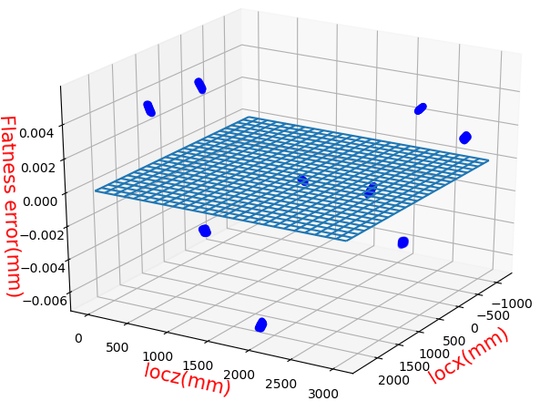
Figure 10 Flatness error of 9 connection points on the interface plate（90 degrees, 6μm）

2 Tipping structure loaded with primary reflector
2.1 Pitch motion
When the equivalent force of the material is less than the proportional limit, the material will be deformed elastically, and it will be restored to its original state after withdrawing the external force; when the equivalent force of the material is more than the proportional limit, the material will be deformed plastically, and it will not be restored to its original state after withdrawing the external force. Since any material must undergo a plastic deformation phase before fracture, it will not fracture if its maximum stress is less than the yield limit of the material.
To ensure that the primary reflector will not be plastic deformed and the tipping structure will not fracture, their equivalent stress cannot exceed the proportional limits of their material. The proportional limit is approximately equal to the yield limit.
The results of the analysis of the tipping structure loaded with the primary reflector are shown in Figures 11-12.

Figure 11. Curve of the maximum stress of the tipping structure loaded with the primary reflector over time. The maximum stress of the tipping structure loaded with the primary reflector is 145.6MPa at the 40th second (corresponds to the hydraulic cylinders’ elongation of 500mm).

Figure 12. Stress result at the 40th second.

The yield limit of the structural steel is σ_{b} = 235MPa.Letting the safety factor be n = 1.5, the maximum permissible stress is
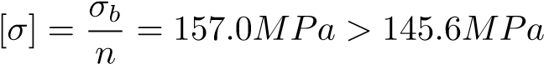 (1)
The tipping structure is safe because the maximum stress is less than the allowable stress value.
To verify the accuracy of this analysis, we extracted the Y-directional reaction force over time for the ”general joint” as shown in Figure 13. From Figure 13, the FEA result is similar to the theoretical calculation result, and the bearable pressure of a single hydraulic cylinder design cannot be less than 140,000N.
Figure 13. Curve of a single hydraulic cylinder’s driving force over time. The solid line is the curve from FEA, and the dashed line is the curve from the theoretical calculation.
In the finite element model, the simulation of the support frame is close to the actual situation, but the simulations of reflecting surface and honeycomb panels in FEA are very different from the actual situation. Therefore, we need to calculate the stress results of the reflecting surface and honeycomb panels based on the stress results of the support frame. We get the stress results for the connection between the honeycomb panels and the support frame (see Figure 14), and the curve of the maximum stress at this position over time is shown in Figure 15.
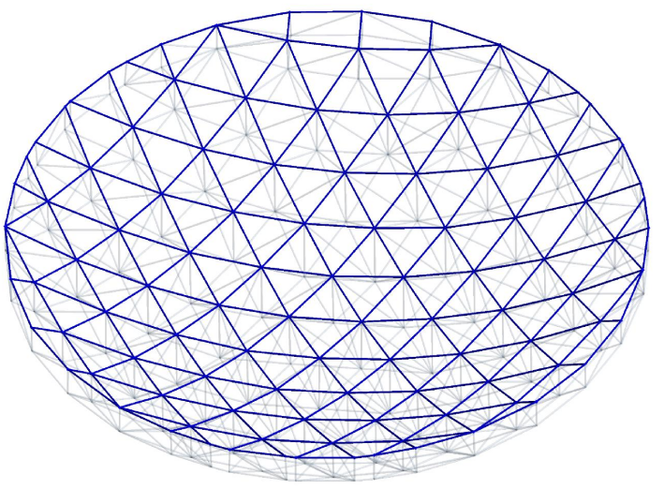
Figure 14. Connection between the honeycomb panels and the support frame.
Figure 15. Curve of the maximum stress at the connection between the honeycomb panels and the support frame over time. The maximum stress of the structure is 19.0 MPa at the 52nd second (corresponds to the hydraulic cylinders’ elongation of 1475mm).
From the strain continuity between the honeycomb panels and the support frame at the connection position, we have
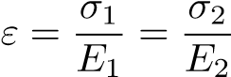 (2)
Where ε is the strain at the connection position, σ₁ and E₁ are the stress and elasticity modulus at the connection position of the support frame, σ₂ and E₂ are the stress and elasticity modulus at the connection position of the honeycomb panels.
The yield limit of the honeycomb panels (aluminum) is σ_{m2} = 30MPa. So the maximum permissible stress on the support frame is
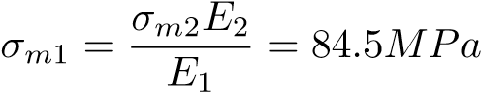 (3)
Letting the safety factor be n = 1.5, the maximum permissible stress on the support frame is
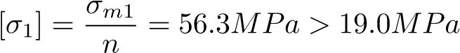 (4)
The primary reflector is safe because the maximum stress is less than the allowable stress value.

2.2 Flatness error of interface plate at three angles

This section shows the flatness error results of the tipping structure’s 9 points connected to the primary reflector (see Figure 16) when the tipping structure is at 0 degrees, 45 degrees, and 90 degrees. All subsequent results use the coordinate system shown in Figure 17.
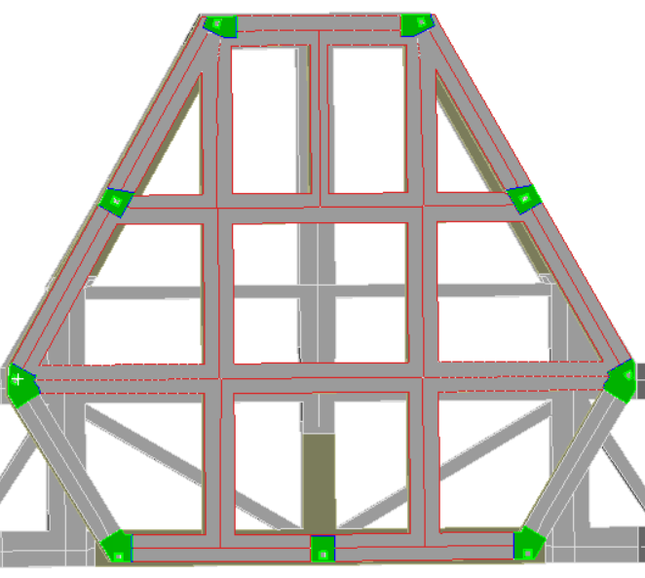
Figure 16 Eight points

Figure 17 The coordinate system

2.1 On horizontal pavement
2.1.1 Static analysis
Figure 18 shows the diagram when the angle between the interface plate and the ground is 0 degrees. Figure 19 shows the coordinate values and deformation values of Y direction. The least squares method is used to fit the plane, and the fitting results are shown in Figure 20, and the fitted planarity error is shown in Figure 21.
Fig.18 0 degrees
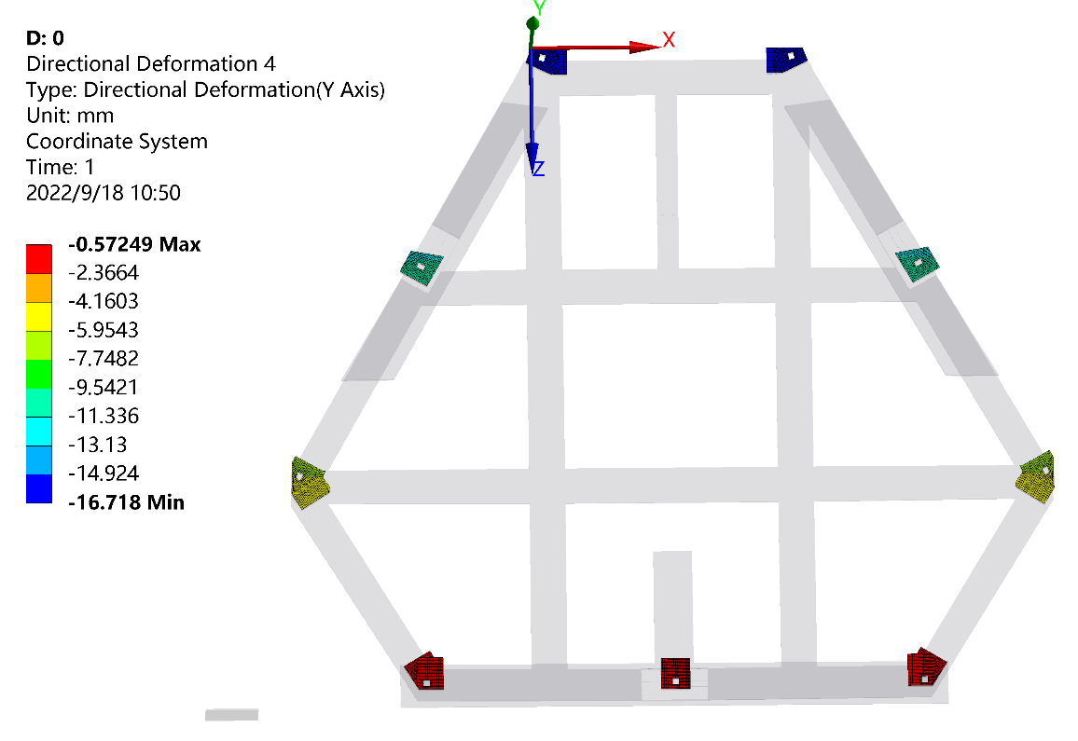
Fig.19 Deformation in the Y direction（0 degrees）

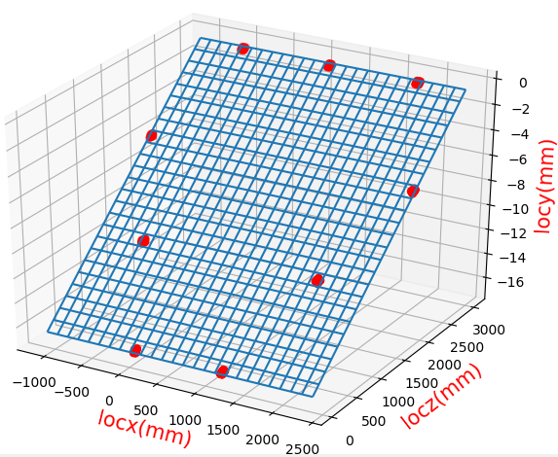
Fig.20 Plane fitting（0 degrees）

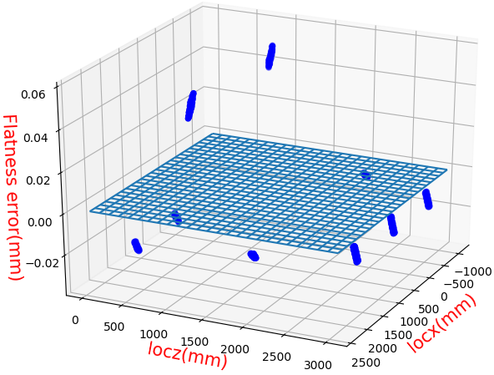
Fig.21 Flatness error diagram（±44μm）
Figure 22 shows the diagram when the angle between the interface plate and the ground is 45 degrees. Figure 23 shows the coordinate values and deformation values of Y direction. The least squares method is used to fit the plane, and the fitting results are shown in Figure 24, and the fitted planarity error is shown in Figure 25.
Fig.22 45 degrees

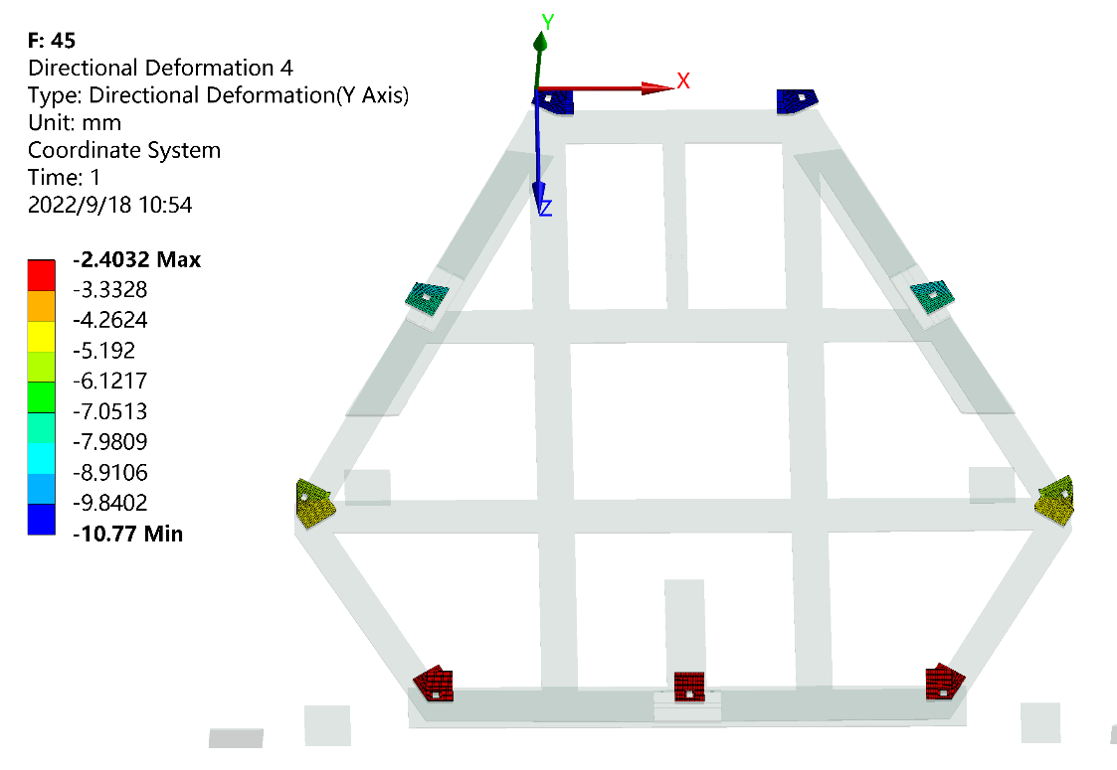
Fig.23 Deformation in the Y direction（45 degrees）

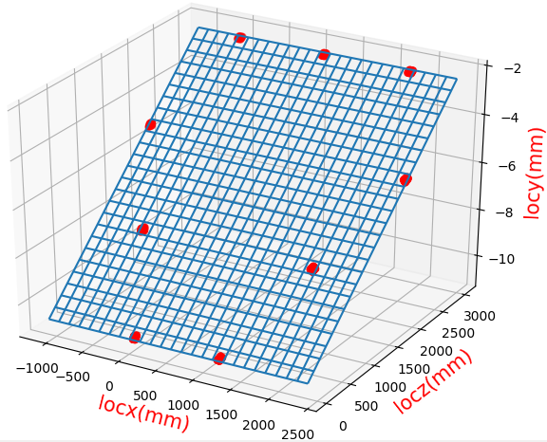
Fig.24 Plane fitting（45 degrees）
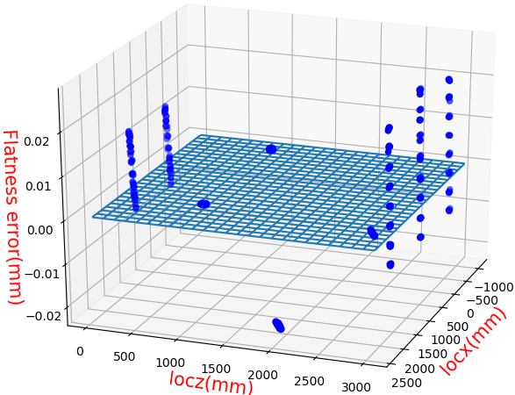
Fig.25 Flatness error diagram（±24μm）
Figure 26 shows the diagram when the angle between the interface plate and the ground is 90 degrees. Figure 27 shows the coordinate values and deformation values of Y direction. The least squares method is used to fit the plane, and the fitting results are shown in Figure 28, and the fitted planarity error is shown in Figure 29.
Fig.26 90 degrees
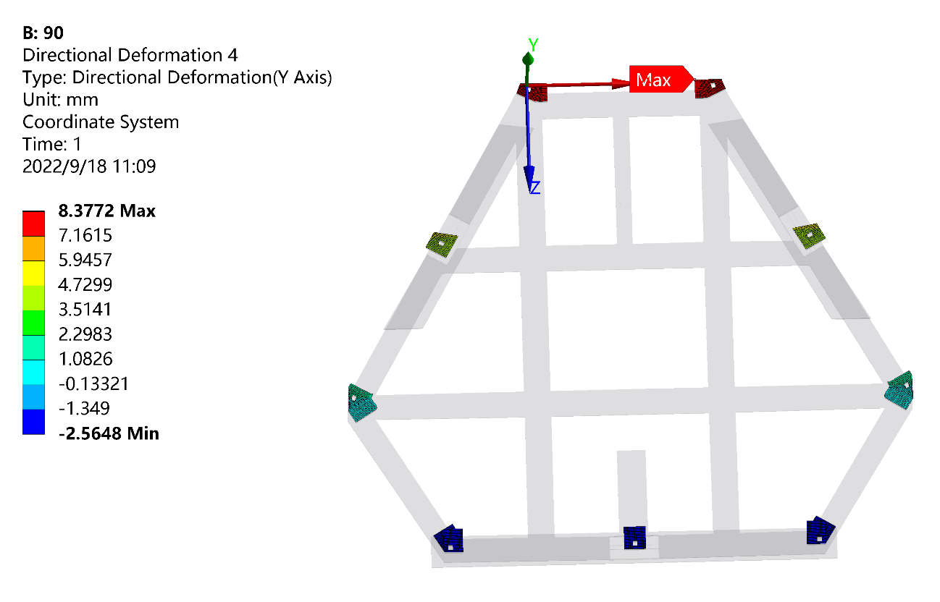
Fig.27 Deformation in the Y direction（90 degrees）
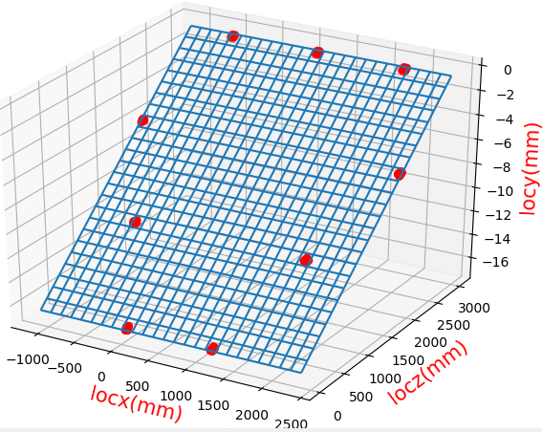
Fig.28 Plane fitting（90 degrees）

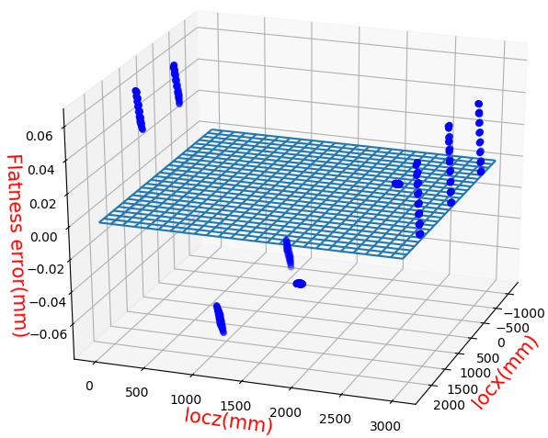
Fig.29 Flatness error diagram（±67μm）

2.1.2 Sinusoidal vibration analysis
Figures 30-32 show the flatness errors of 9 points when the bottom of the tipping structure vibrates in the vertical direction with an amplitude of 5mm and a period of 0.1s on the horizontal pavement.

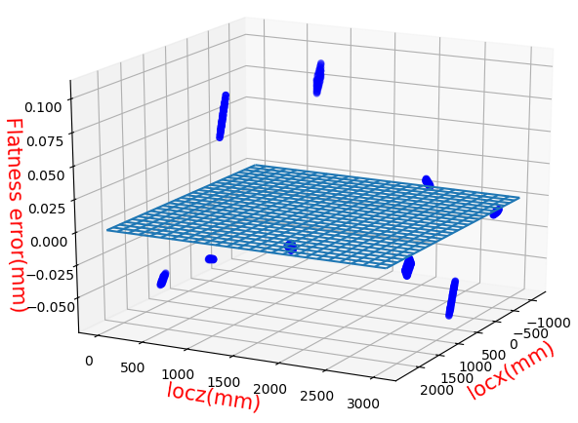
Figure 30 Tipping structure at 0 degrees(±83μm)
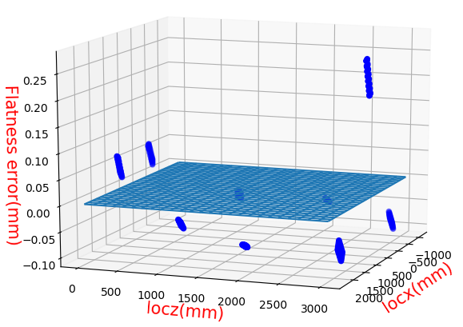
Figure 31 Tipping structure at 45 degrees(±129μm)
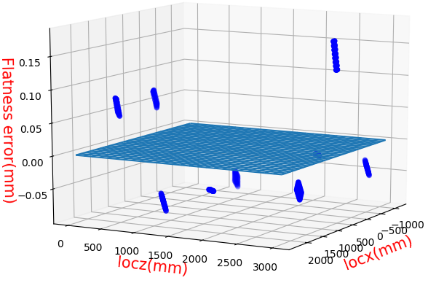
Figure 32 Tipping structure at 90 degrees(±127μm)

2.2 On a 20-degree slope
2.2.1 Static analysis
Figures 34-36 show the flatness errors of 9 points when the truck is on a 20-degree slope (see figure 33).
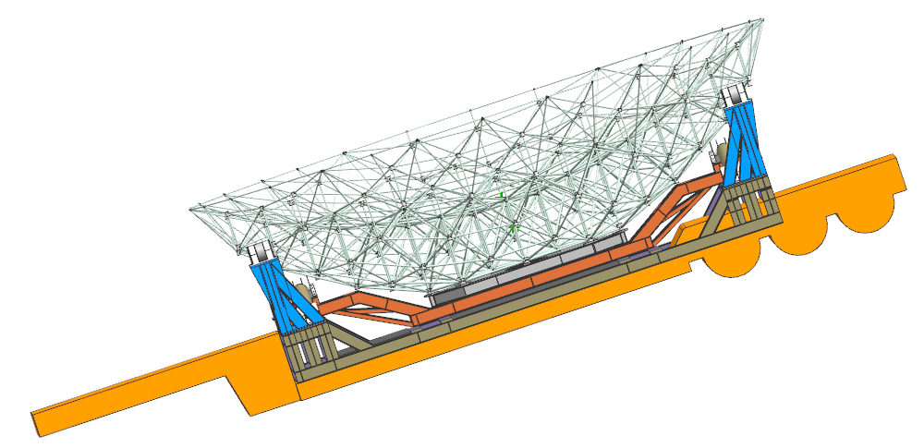

Figure 33 Transport on a 20-degree slope
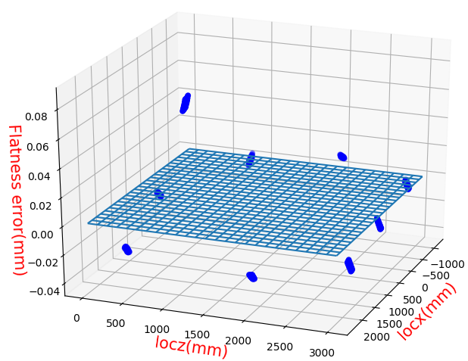
Figure 34 Tipping structure at 0 degrees（±63μm）
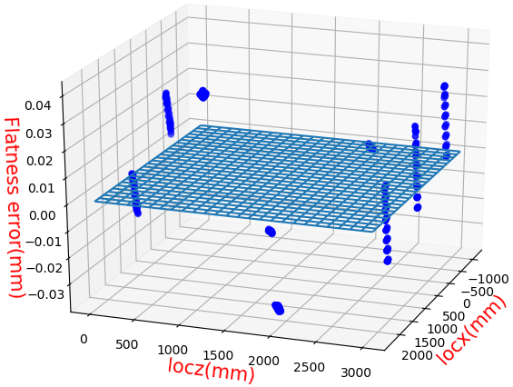
Figure 35 Tipping structure at 45 degrees（±38μm）
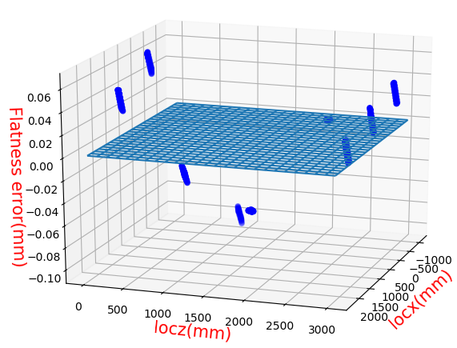
Figure 36 Tipping structure at 90 degrees（±81μm）

2.2.2 Sinusoidal vibration analysis
Figures 37-39 show the flatness errors of 9 points connected to the primary reflector when the truck vibrates with an amplitude of 5mm and a period of 0.1s perpendicular to the road on a 20 degrees slope.
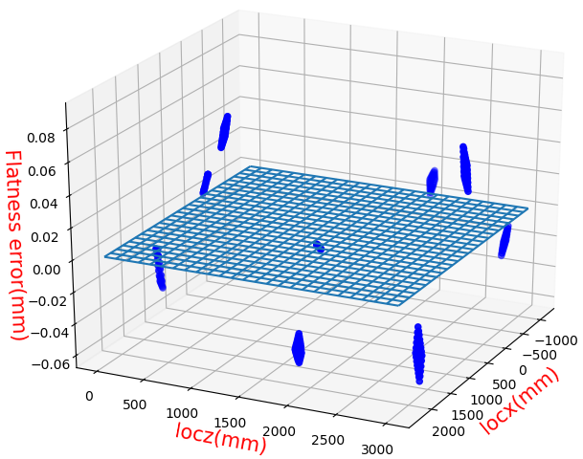
Figure 37 Tipping structure at 0 degrees（±71μm）
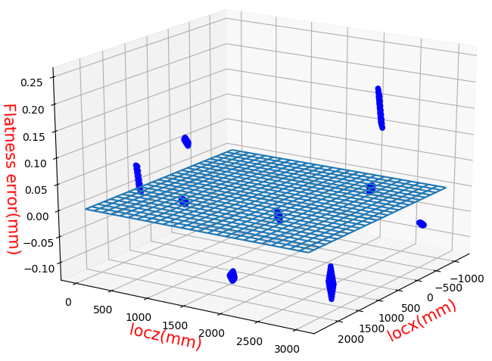
Figure 38 Tipping structure at 45 degrees（±175μm）
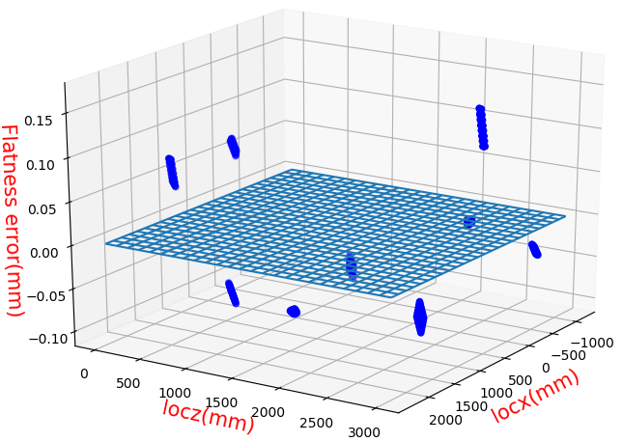
Figure 39 Tipping structure at 90 degrees（±131μm）

3 Randon vibration

3.1. Vibration analysis
To evaluate the possibility of fracture of the tipping structure and plastic deformation of the primary reflector during the transportation process, we need to conduct a random vibration analysis of the tipping structure loaded with the primary reflector. During transportation, the tipping structure has two states, horizontal and vertical, so we analyzed these two states separately.
3.1.2 Modal analysis
Modal analysis is used to obtain the inherent vibration characteristics of a structure, i.e., the modal frequency and modal shape of the structure. When an object vibrates freely, its displacement varies over time under the sinusoidal law. The free vibration frequency of the structure is called the “modal frequency”, which is independent of the initial conditions. Each modal frequency corresponds to a vibration state, which is called “modal shape”. An arbitrary structure has an infinite number of mode shapes and therefore it also has an infinite number of modal frequencies. Ranking the modal frequencies from low to high, the higher-order modal frequencies are less influential on the vibration analysis results than the lower-order. Therefore, We usually consider only the first 20 to 40 orders of modes in analysis.
As shown in Figure 40, we added some support members between the base and the tipping frame to increase the modal frequency.
Figure 40. Auxiliary support diagram when the tipping structure is in the horizontal state
We fixed the bottom surface of the tipping structure and conducted a modal analysis for the first 40 orders. The modal frequencies and modal shapes of the first 6 orders are shown in Figures 41-22. To depict the results more concisely, we organized the results of Figures 41-42 into Tables 1-2.
Figure 41. Modal frequencies and modal shapes of the tipping structure when it is in the horizontal state. The primary reflector is hidden.

Table 1. Modal frequencies and modal shapes of the tipping structure when it is in the horizontal state
Modal orders | 1 | 2 | 3 | 4 | 5 | 6
Modal frequencies (HZ) | 3.17 | 4.08 | 7.99 | 16.24 | 20.88 | 21.38
Modal shapes | Rotation X | Rotation Y | Translation Z | Rotation Z | Rotation Y | Translation Z

Figure 42. Modal frequencies and modal shapes of the tipping structure when it is in the vertical state. The primary reflector is hidden.

Table 2. Modal frequencies and modal shapes of the tipping structure when it is in the vertical state
Modal orders | 1 | 2 | 3 | 4 | 5 | 6
Modal frequencies (HZ) | 1.95 | 2.52 | 4.25 | 7.35 | 10.03 | 11.25
Modal shapes | Rotation X | Rotation Z | Translation Y | Translation X | Rotation Y | Translation Z

During transportation, the excitation is mostly in the Z-direction, so the mode frequency corresponding to “translation Z” is more likely to cause resonance. According to Tables 1-2, the minimum frequency of “translation Z” is 7.99HZ when the tipping structure is in the horizontal state, and the minimum frequency of “translation Z” is 11.25HZ when it is in the vertical state.

3.1.3. Random vibration analysis
Power spectral density (PSD) is a physical quantity that characterizes the relationship between power energy and frequency. This section uses PSD to simulate the road conditions and analyze the random vibration in land transportation.
The random vibration analysis is based on modal analysis. The input of the random vibration analysis is the PSD shown in Table 3 and the output is the results that obey the standard normal distribution(see Figure 43).
Table 3. PSD used to simulate the road conditions during land transportation .
Frequency(HZ) | 1 | 2 | 3 | 4 | 6 | 20 | 28 | 50 | 60 | 100
PSD(g²/HZ) | 0.0001 | 0.0002 | 0.002 | 0.002 | 0.00005 | 0.0006 | 0.0006 | 0.00008 | 0.00008 | 0.000005
Figure 43. Probability density curve of standard normal distribution. The stress results at any node in the model obey the law of standard normal distribution. The horizontal coordinate is the possible values of stresses and the vertical coordinate is the probability density.

The random vibration analysis can get the equivalent stress results of shell and solid elements and the normal stress results of beam elements, where the normal stress direction of beam elements is axial. According to the third strength theory, if the maximum normal stress exceeds the yield limit of the material, the material will be plastically deformed .
The results of the random vibration analysis when the tipping structure is in the horizontal and vertical state are shown in Figures 44-47. From equation (6), the maximum stress tolerated by the tipping structure is 157.0 MPa, which is greater than 138.3 MPa (see Figure 44) and 142.0 MPa (see Figure 46). From equation (9), the maximum stress tolerated by the support frame is 56.3 MPa, which is greater than 40.8 MPa (see Figure 45) and 12.9 Mpa (see Figure 47). So the probability of fracture of the tipping structure or plastic deformation of the primary reflector during land transportation is almost 0.
Figure 44. Random vibration analysis results when the tipping structure is in the vertical state. In this figure, the maximum stress of the tipping structure is 138.3 MPa.The stress at all nodes in the model corresponds to “3σ” in Figure 43.
Figure 45. Random vibration analysis results when the tipping structure is in the vertical state. In this figure, the maximum stress of the support frame is 40.8 MPa.The stress at all nodes in the model corresponds to “3σ” in Figure 43.
Figure 46. Random vibration analysis results when the tipping structure is in the vertical state. In this figure, the maximum stress of the tipping structure is 142.0 MPa.The stress at all nodes in the model corresponds to “3σ” in Figure 43.
Figure 47. Random vibration analysis results when the tipping structure is in the vertical state. In this figure, the maximum stress of the support frame is 14.9 MPa.The stress at all nodes in the model corresponds to “3σ” in Figure 43.

5 Other analysis
Figure 48 shows the three locations where the interface plate is connected to the tipping structure. Each connection position has 8 M20 bolts, as shown in Figure 49.
Figure 48 Three connection positions
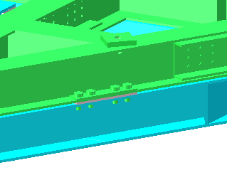
Figure 49 Details of the connection positions
The forces at the three connection positions when the tipping structure is at 90 degrees and 45 degrees are shown in Table 4. Since the bolts of a single M20 can withstand a force of 188KN, which is much greater than the datas shown in table 4, the bolts are safe.

Table 4 The forces at three connection positions
 | 1 | 2 | 3
For 45 degrees（N） | 20671 | 20695 | 29500
For 90 degrees（N） | 32043 | 32033 | 38642

The stress of the structure connected with bolts is shown in Figure 50-51. The yield limit of the structure is 235MPa, which is much higher than the stress of the structure. Therefore, the structure is safe.
Figure 50 The stress of the structure connected with bolts（for 45 degrees）
Figure 51 The stress of the structure connected with bolts（for 90 degrees）

Figure 52 shows 9 connection points between the interface plate and the primary reflector. The forces on 9 connection points when tipping structure is at 45 degrees and 90 degrees are shown in Table 5.
Figure 52 Nine connection bolts

Table 5 The forces on 9 connection points
 | 1 | 2 | 3 | 4 | 5 | 6 | 7 | 8 | 9
For 45 degrees（N） | 2394 | 2403 | 10284 | 10241 | 3854 | 3846 | 8578 | 26100 | 8537
For 90 degrees（N） | 2193 | 2207 | 18712 | 18877 | 6411 | 6469 | 5547 | 32218 | 5458

