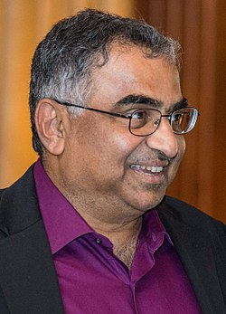
S. R. Kulkarni
I am the George Ellery Hale Professor of Astronomy & Planetary Sciences at the California Institute of Technology. I did my undergraduate studies at the Indian Institute of Technology, Delhi and got my PhD in radio astronomy at UC Berkeley in 1983 (Advisors: Carl Heiles & Donald Backer). I joined Caltech in 1985 and have been here ever since. I served as the Executive Officer for Astronomy (1997-2000) and the Director of Caltech Optical Observatories for the period 2006-2018. I was recognized by Cornell University with an AD White Professor-at-large appointment and received an honorary doctorate from the Radboud University of Nijmegen, The Netherlands. I chair the Physical Sciences panel. I thank the taxpayers of India & the state of California for funding my formal education.

My modus operandi (MO) has been to avoid popular fields and instead identify interesting topics and make inroads and ideally great progress and then leave that field once either it becomes popular or I have made tremendous progress. Highlights of my career: the discovery of the first millisecond pulsar, the first brown dwarfs, identifying soft-gamma ray repeaters as Galactic objects, the demonstration that gamma-ray bursts are of cosmological origin and showing that some (most) FRBs come from magnetars). I founded the Palomar Transient Factory (PTF) and the Zwicky Transient Facility. These projects seemed to have been instrumental in the development of optical time domain astronomy.

I have advised or co-advised 34 graduate students and mentored 54 postdoctoral fellows. For additional details please see my homepage.

Kulkarni’s awards include the Alan T. Waterman Prize of the US National Science Foundation (NSF), a fellowship from the David and Lucile Packard Foundation, a Presidential Young Investigator award from the NSF, the Helen B. Warner award of the American Astronomical Society, the Karl Jansky Lecturer of Associated Universities, Inc, the Dan David Prize and the Shaw Prize.
Kulkarni is a fellow or member of the following learned societies: the American Academy of Arts & Sciences, the Royal Society of London, the US National Academy of Sciences, Indian Academy of Sciences and the Royal Netherlands Academy of Arts and Sciences (KNAW). Fritz Zwicky, George Ellery Hale and Jan Oort are my heroes.

